Batch: B2 – H5 Roll No.: 16010121200
Experiment No. 02

Title: Google analytics for your website

Objective:
Define Social media strategy while considering social media pillars, social business intelligence and social media strategy framework.

Expected Outcome of Experiment:

CO | Outcome
CO3 | Apply software processing techniques to prepare statistical modelling for geospatial healthcare and text data

Books/ Journals/ Websites referred:
- Data Mining Concepts and Techniques Jiawei Han, Michelin Kamber, Jian Pie, 3rd edition

Task to be performed:
1. Use hosted website or page or host your test page
2. Create account on Google analytics
3. Get GA id and add to your website or page
4. Share the website/page in your circle
5. Explore various options on dashboard of Google analytics
6. Generate the report
Note: Students can use their mobile Application instead of website or page/ or YouTube video channel.

Name of your website: RFit
Analytics:
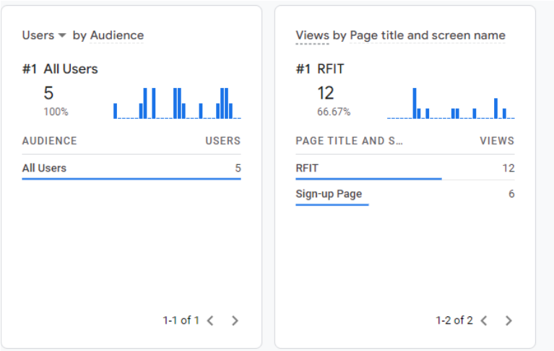
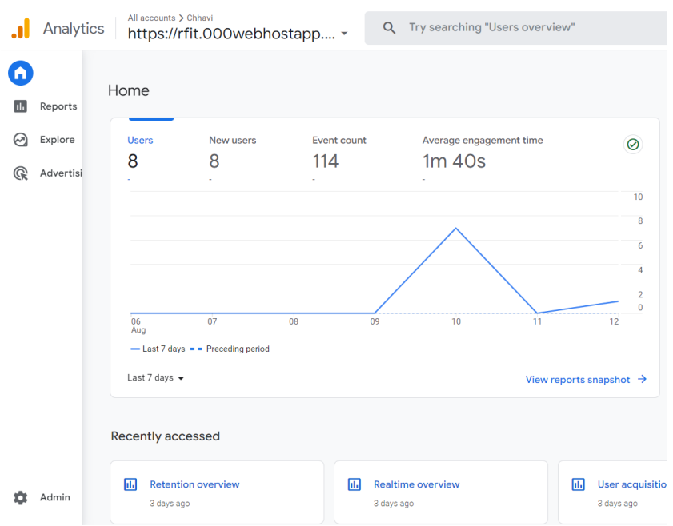

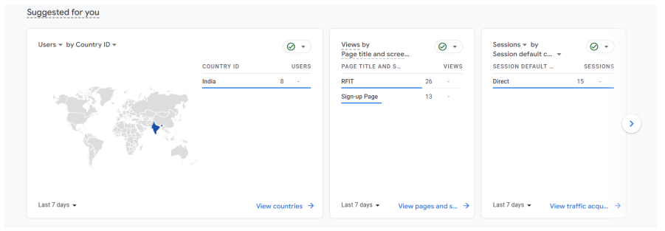
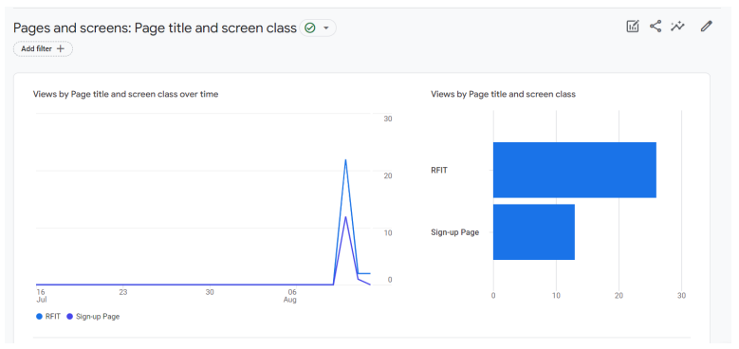
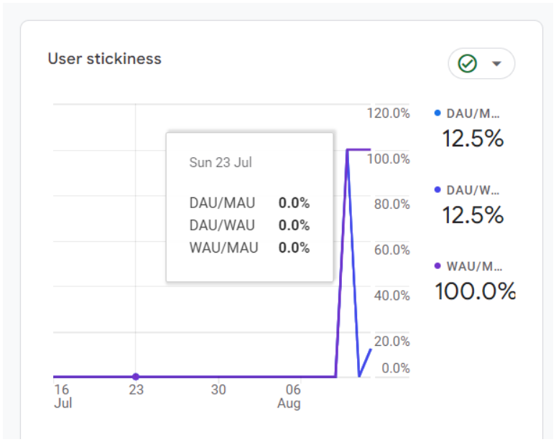
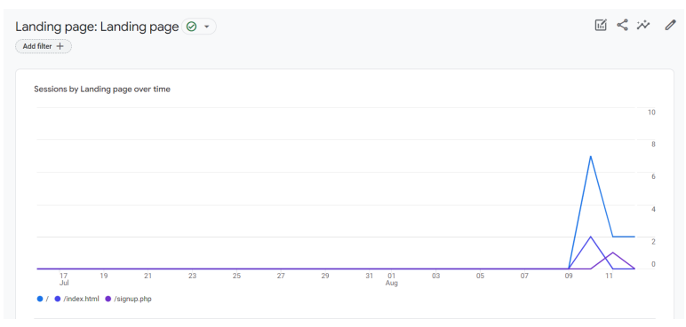
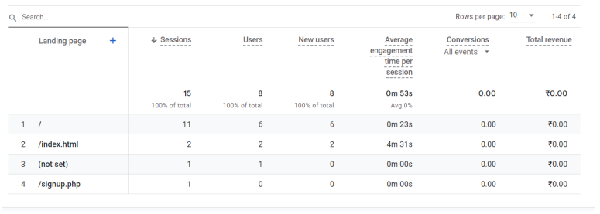
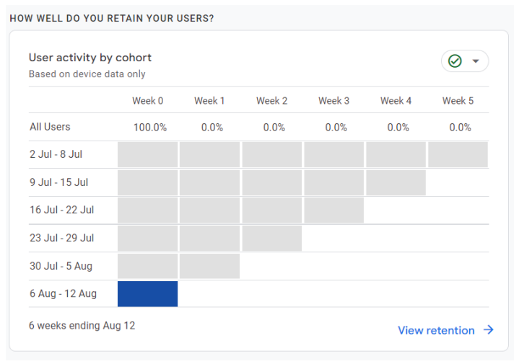
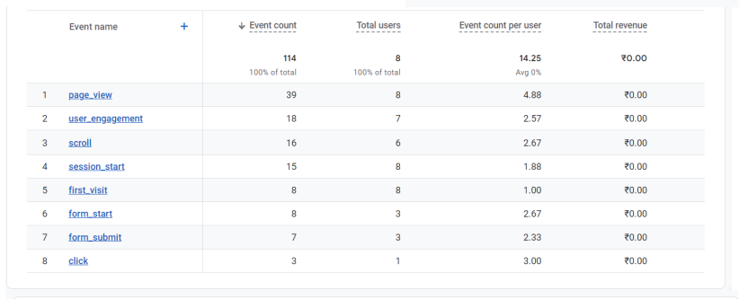
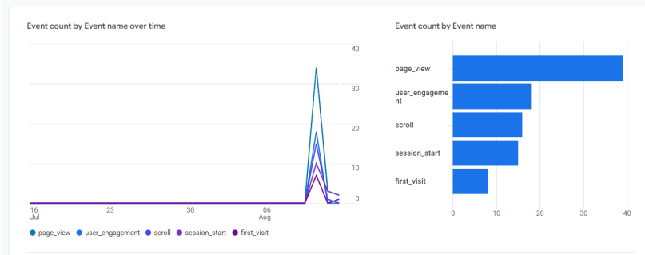
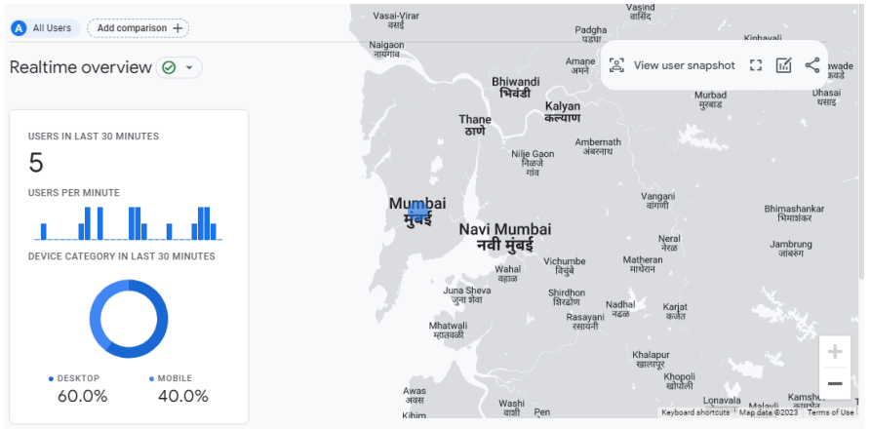

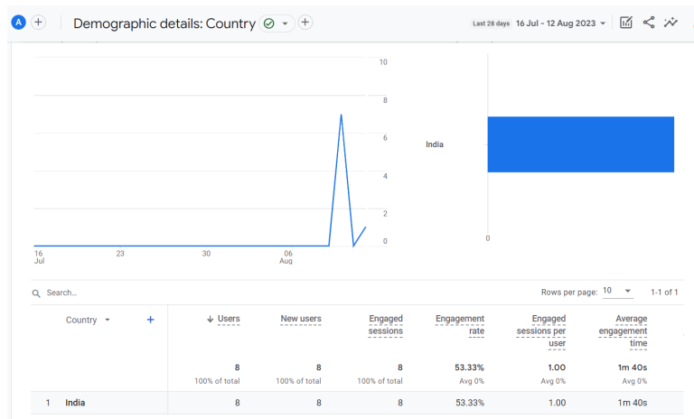
Post-lab questions:
- Comment on your experience with setting up Google Analytics for your website.

Setting up Google Analytics for my website introduced me to a lot of interesting insights about the traffic that my website gets. Initially, it might seem a bit technical, but the process is well-documented and guided by Google's instructions. Once set up, K. J. Somaiya College of Engineering, Mumbai-77 (Autonomous College Affiliated to University of Mumbai) Department of Computer Engineering DA Sem-IV – Aug-Dec2022 Google Analytics provides a wealth of information about your website's visitors, their behaviour, and the effectiveness of your marketing efforts. It's fascinating to see real-time data and trends, such as the number of visitors, their geographic locations, popular pages, referral sources, and more. Overall, the experience of setting up Google Analytics is rewarding, as it equips you with valuable data to optimize your website's performance.

- Differentiate between Google Analytics and Facebook analytics.

While both Google Analytics and Facebook Analytics provide insights into online user behaviour, they are tailored to different platforms and offer distinct features: Platform: Google Analytics focuses on website traffic and user behaviour, whereas Facebook Analytics primarily tracks interactions within the Facebook ecosystem, such as interactions with Facebook Pages, posts, and ads. Scope: Google Analytics provides a comprehensive view of website traffic, user demographics, and conversions. In contrast, Facebook Analytics emphasizes user engagement and behaviour specifically on Facebook properties. Integration: Google Analytics can be integrated with various platforms beyond your website, providing a broader perspective on user interactions. Facebook Analytics, on the other hand, is inherently linked to the Facebook platform. Data Sources: Google Analytics uses data from websites, while Facebook Analytics uses data from Facebook-related activities. Audience: Google Analytics caters to website owners and marketers seeking to understand website performance. Facebook Analytics is more suitable for businesses heavily engaged in Facebook marketing and seeking insights into their Facebook audience.

- Discuss significance of Google Analytics and insights in decision making process.

Data-Driven Decisions: Google Analytics provides accurate, real-time data about user behaviour, traffic sources, conversion rates, and more. This data helps businesses make informed decisions based on actual user interactions rather than assumptions. Performance Evaluation: It allows you to assess the effectiveness of marketing campaigns, content strategies, and user experience enhancements. By tracking metrics such as bounce rates, session duration, and conversion rates, you can identify what's working and what needs improvement. User Insights: Google Analytics helps you understand your audience demographics, interests, and behaviours. This information enables you to tailor your content and marketing efforts to better serve your target audience.

ROI Measurement: You can track the ROI of various marketing initiatives, whether they are paid advertisements, social media campaigns, or content creation. This data helps allocate resources more effectively. Goal Tracking: Google Analytics lets you define and track specific goals, such as purchases, sign-ups, or downloads. This aids in measuring the success of your website in achieving its intended outcomes.

Conclusion:
Explored the google analytics tool and used it to insights about user behaviour, traffic sources, conversion rates etc. This information will be helpful to us to take data driven decisions in order to increase website viewership and user retention.

